# Light Monitoring for Plants using Bolt

# https://files.readme.io/f84a249-slide3_kLxILLlSHL.jpg

# THINGS used in this project :

## Hardware componenthttps://files.readme.io/8238d49-bolt_Sr5J0aNLB0.jpeg . Bolt IoT Bolt WiFi Module

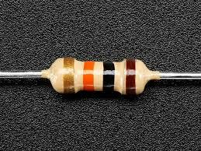 . Resistor 10k ohm

## 

* Light Dependent Resistor 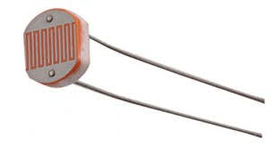

## Software apps and online services

* Bolt IoT Bolt Cloud

Let's start

## Step 1: Building the circuit

1. Make sure you have not powered on your Bolt Module while connecting the circuit. This will ensure that in case we make any mistake, it will not short circuit your device. Switch off the power if it is connected.

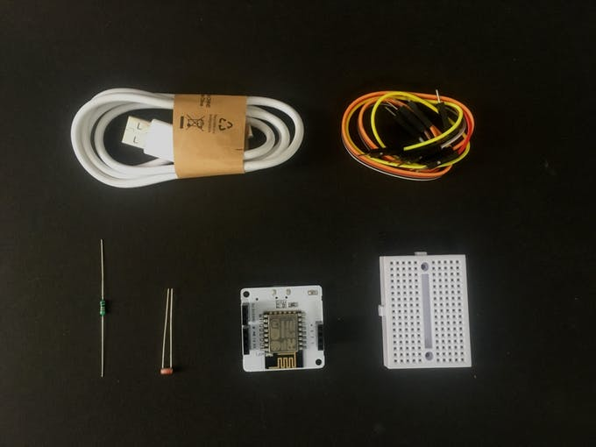

1. Connect one end of the LDR to the A0 (analog) pin of the Bolt device and other ends of the LDR to the 5V pin of the Bolt as shown in the image below.

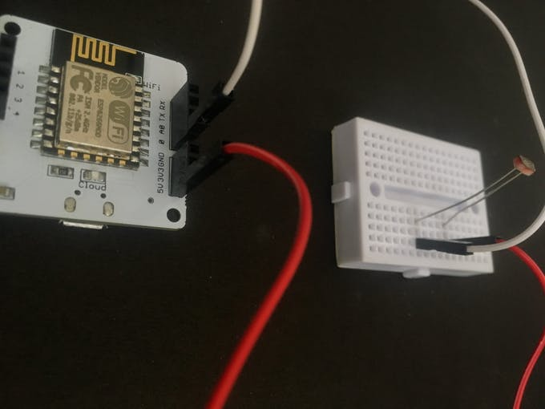

1. Connect the 10K ohm resistor between the GND and A0 pin of the Bolt so that LDR and the resistor form a series connection.

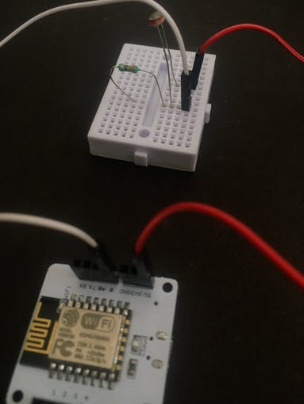

1. We are using breadboard for making the circuits. Now power on the device.

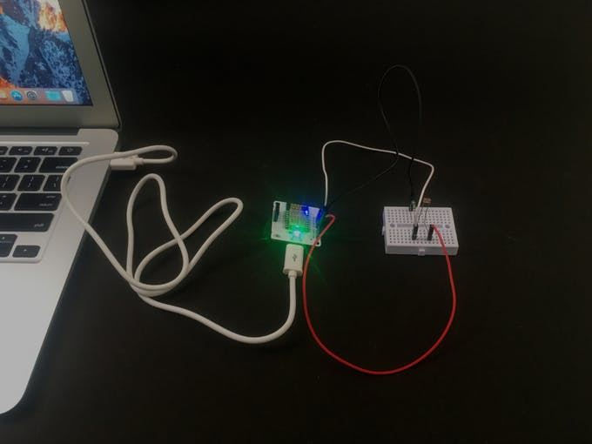

### Step 2: Visualizing the plot

Now we need to visualize the light data on the Bolt cloud.

For the steps to make a line graph go on https://cloud.boltiot.com/

CODE :

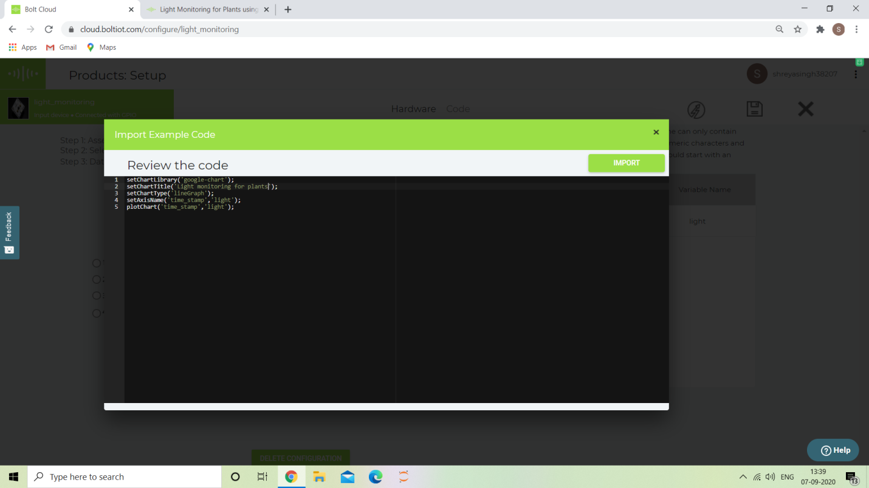

Now let me explain each line of the code so that you could make suitable changes as you wish.

setChartLibrary function sets the Data Visualization Library you would use. The most commonly used one on Bolt Cloud is the Google Library. However, you could use any other JavaScript or HTML code here to visualize the data.

setChartTitle function sets the Title of the Chart/Graph. Give a suitable name for your graph here which will be shown in the heading of the page. This is different from the name of the code file.

setChartType function is where you choose which type of chart you want i.e. Line Graph, Bar Graph etc.

setAxisName will set the name for the X Axis and Y Axis

plotChart is where you choose which variable you want to choose in your chart.

## Working principle

This project is based on the principle that whenever the light falling on the sensor changes, the resistance of sensor changes which is then converted into a change in voltage. The ADC pin on Bolt WiFi Module converted this analog voltage level into digital values which are shown on the graphs.

We connect the LDR between 5v pin and the analog input pin (A0), so that when light intensity increases, the resistance of LDR decreases so the voltage across the LDR decreases and as a result, the voltage on the analog input pin increases.

This means that as the **light intensity increases, the voltage on the analog input pin also increases**. The Bolt then converts that the voltage a 10 bit (10 places in binary number system) digital value that varies from 0-1024 (0 to 2 raised to 10).

This digital data is then sent to the cloud where it is plotted for visual representation.

OUTPUT PLOT

In this graph the value for how much light is received by the plants is 384. For the conversion in centigrade we need to divide the given value by 10.24. So the amount of light received by light is

37.4

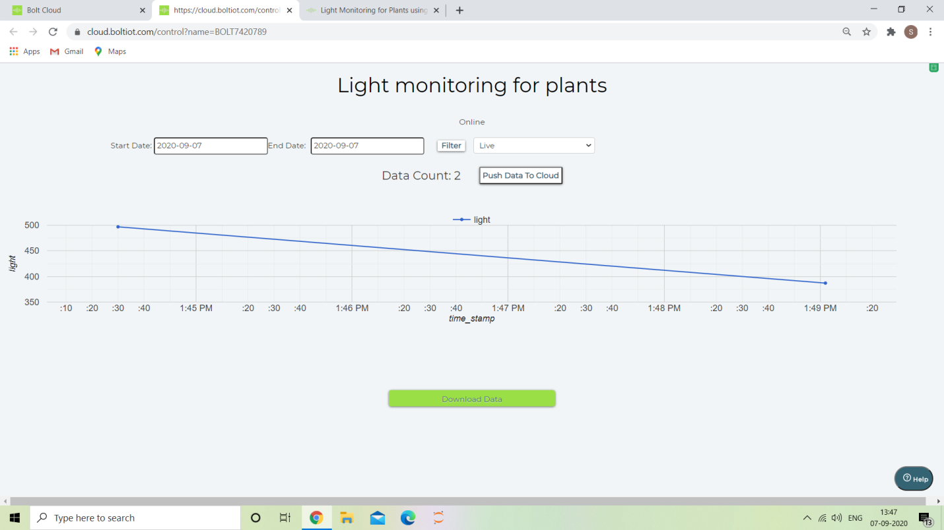

THANK YOU